SUDHIR EQUIPMENT RENTAL COMPANY CR :2050130053
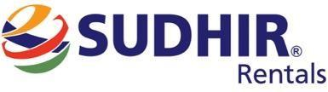

OWNERSHIP CERTIFICATE

To Whom It May Concern

This is to certify that the following equipment listed below is the sole property of
Sudhir Equipment Rental Company:

Equipment | Welding Machine
Brand / Make | ADOR
Asset ID | SWM-500-063
Model Number | RHINO D 500
Serial Number | 26/26010261
Manufacturing Year | 2025

This certification is issued to confirm the ownership status of the aforementioned equipment. Sudhir Equipment Rental Company holds full legal ownership rights over the listed equipment and retains all associated benefits and responsibilities. Should there be any queries or requests for verification regarding the ownership of the mentioned equipment, please do not hesitate to contact us at : Info@sudhirrentals.com


Sincerely,
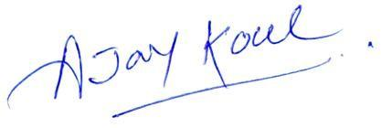

Ajay Koul
General Manager
Sudhir Equipment Rental Company

WWW.SUDHIRRENTALS.COM
